September 2020
Hello Class of 2021!
If you plan on attending college or university next year, you will need to provide your grades to the schools you apply to. This will happen in several ways depending on the schools’ preference (which they will notify you of). One of those ways is to complete the STS Form (transcript and certificate form:
Go to:
https://www2.gov.bc.ca/gov/content/education-training/k-12/support/transcripts-and-certificates
Here is what it looks like:
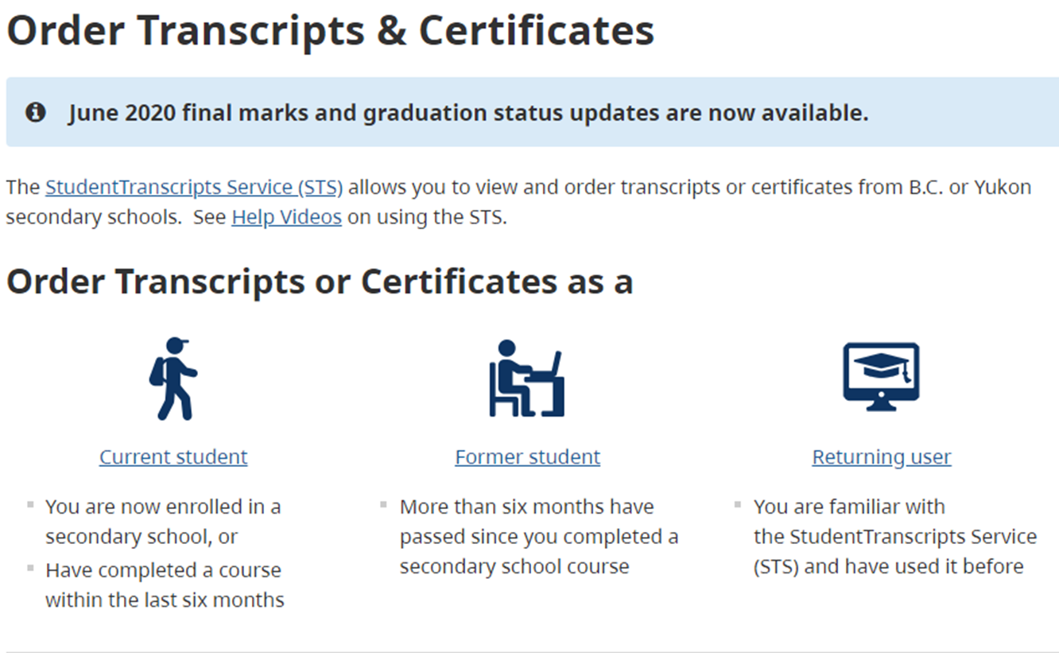Click on “Current student”
Then:
Click on “Register for a Basic BCeID

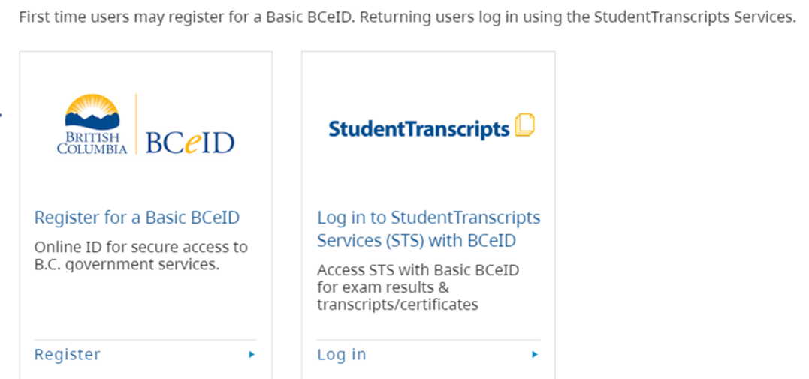
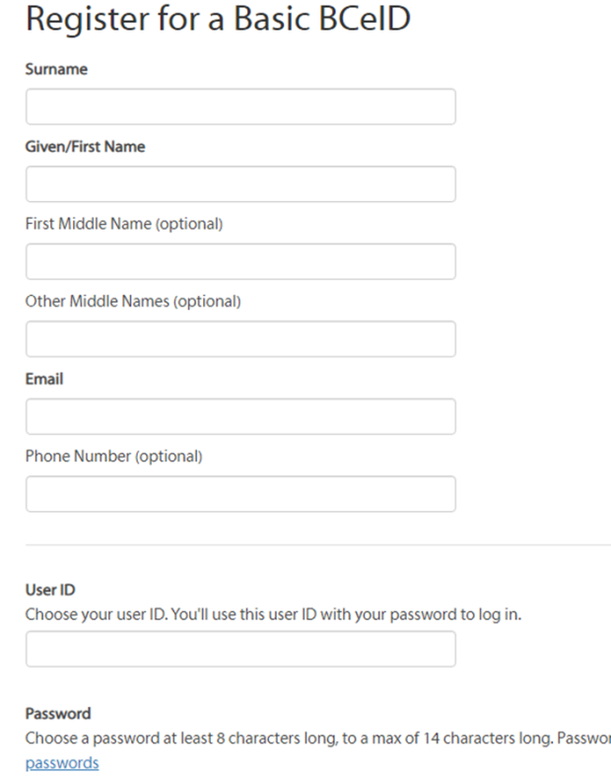
Register your BCeID by clicking the “Register for a Basic BCeID” button. READ the instructions and complete the fields required on the form. Make note (that means write down) the user name and password you created. Once you have done this, you will get an email asking you to activate your account. Close your browser (this step is very important, if you do not close the browser, this may not work); then open your email to find the email from BCeID (DO NOT OPEN ON YOUR PHONE). By opening the email, your account will be activated. Then go back to:
https://www2.gov.bc.ca/gov/content/education-training/k-12/support/transcripts-and-certificates
Now use the “Log in with BCeID” button to log into the site by clicking on “Returning user”. The page looks like this.

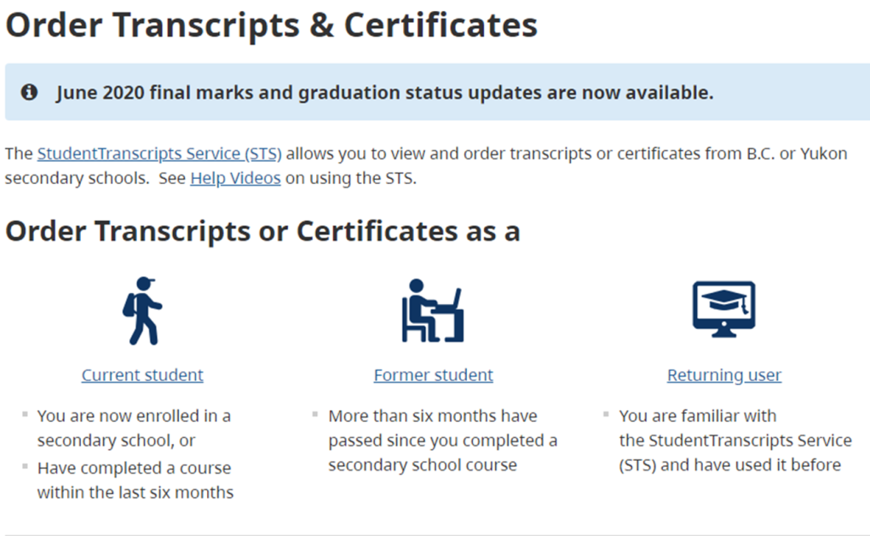

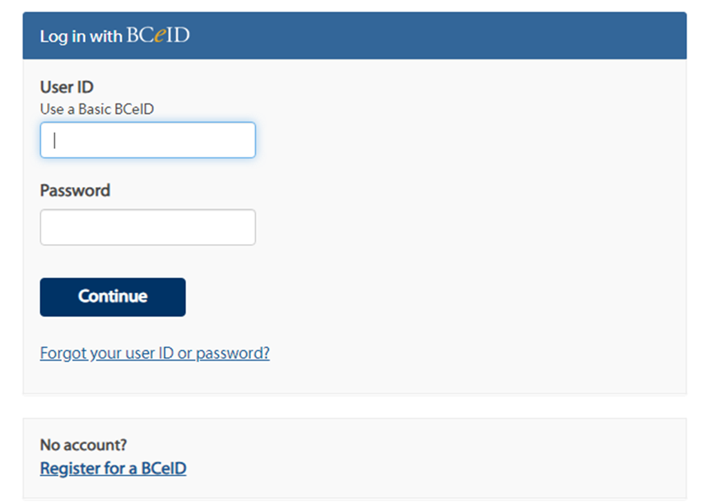

Now click, “send/order transcripts”

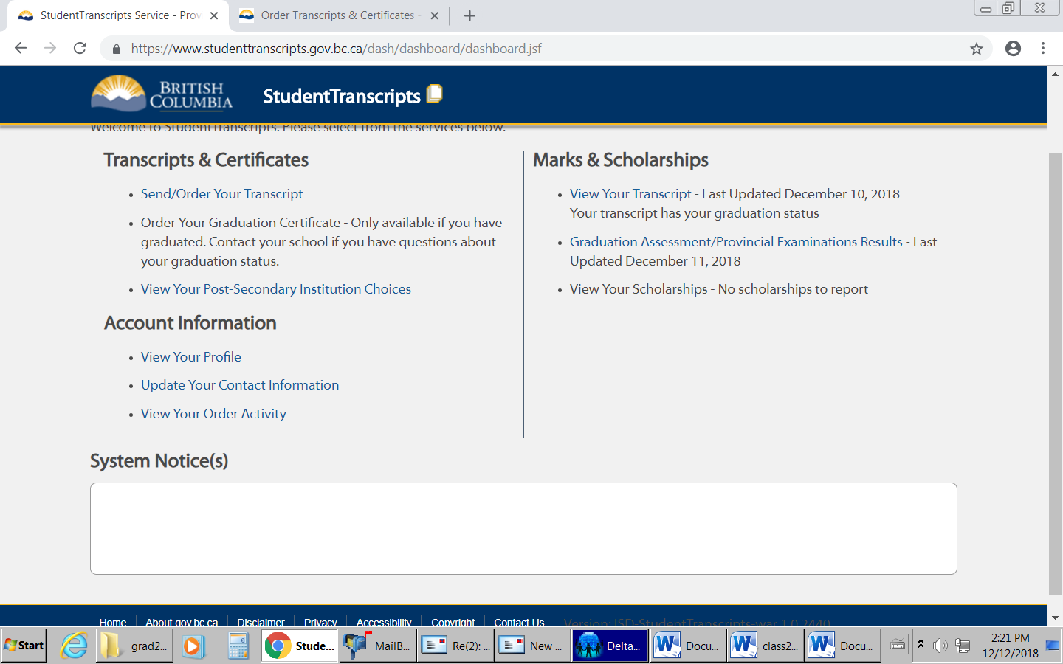

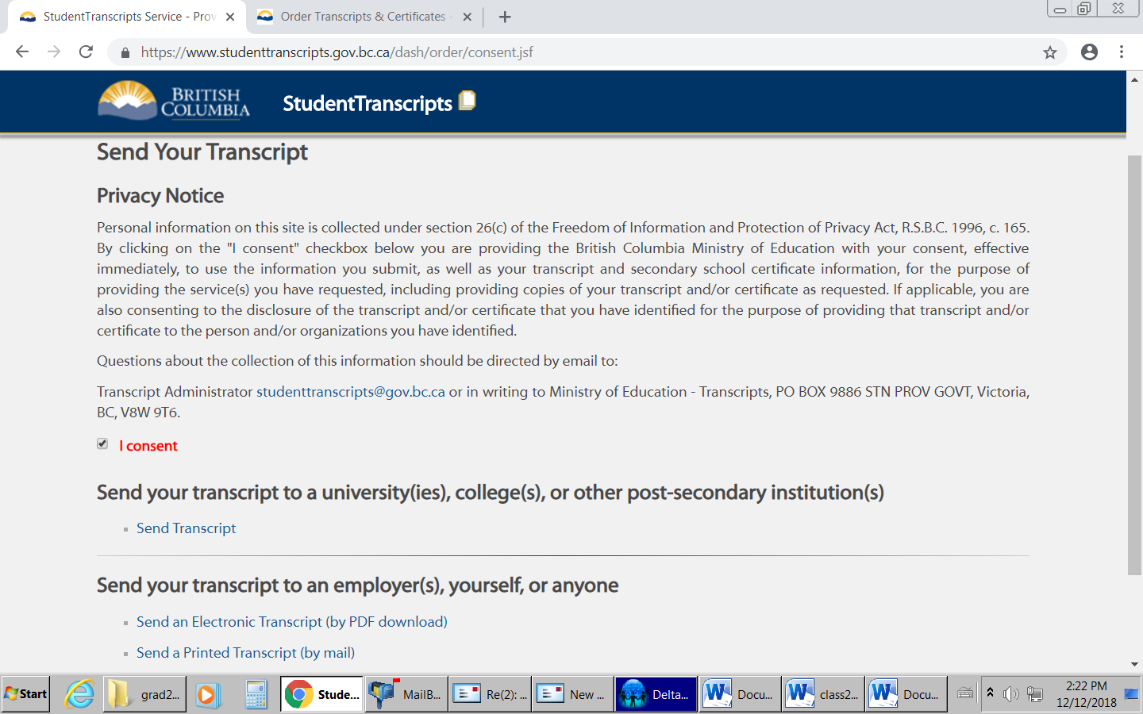
Check the, “I consent” box, then select send transcript

This page defaults to BC PSIs. Select the PSIs from the list by highlighting the name, then click move to list. Repeat the process for all schools you applied to or are planning on applying to. To switch provinces, use the pull down menu.
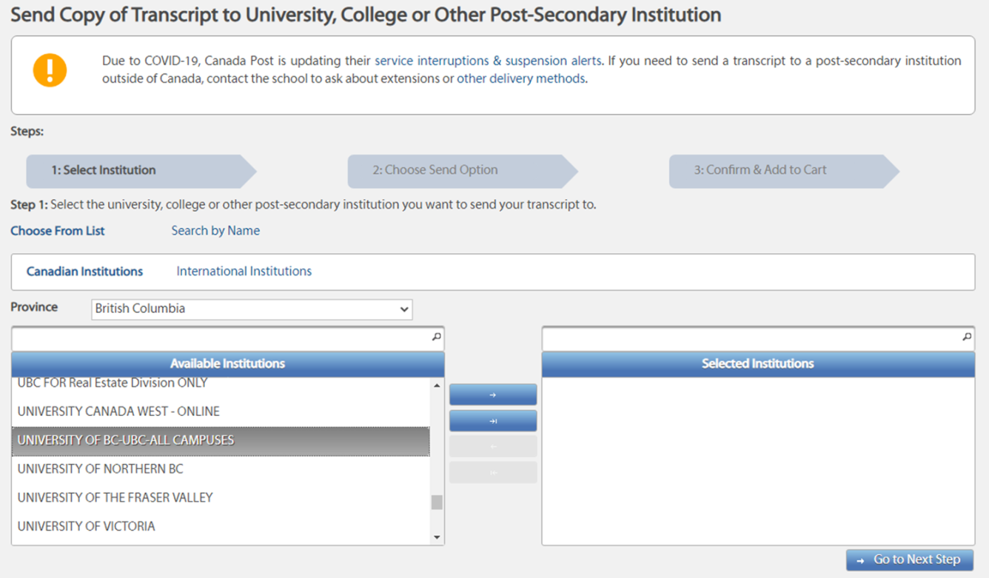
For schools outside of Canada
Drop down for other provinces
Then click, “Go to Next Step”
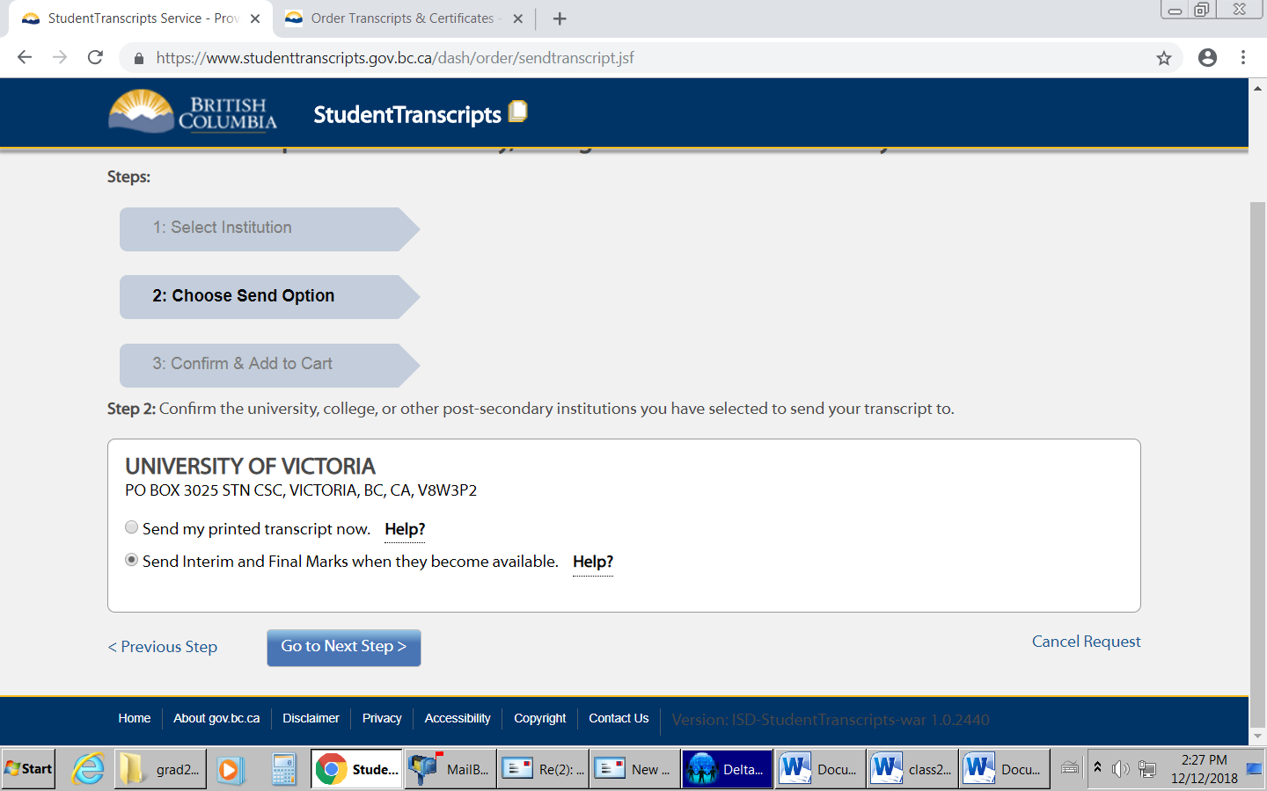
Do not choose Send my printed transcript NOW
The next step is to click the appropriate button which will default to the option each PSI wants. In the example above it is “send interim and final marks…”
DO NOT CHOOSE “SEND MY PRINTED TRANSCRIPT NOW”
Go to Next Step
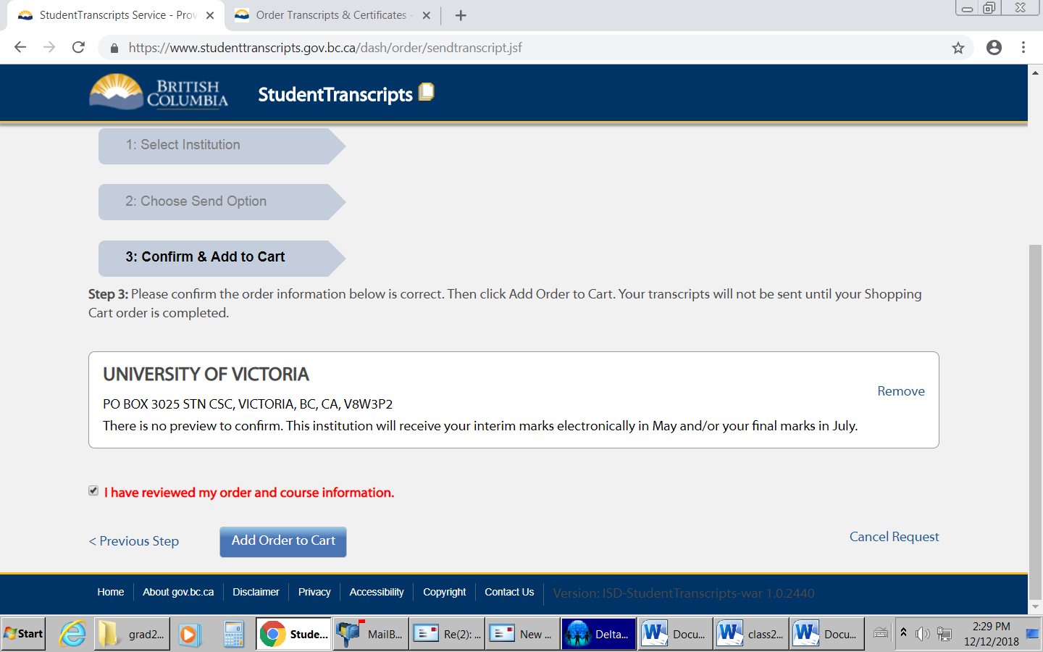
Check the “I have reviewed my order”, then add to cart, then submit.
For some schools, it will look like this.
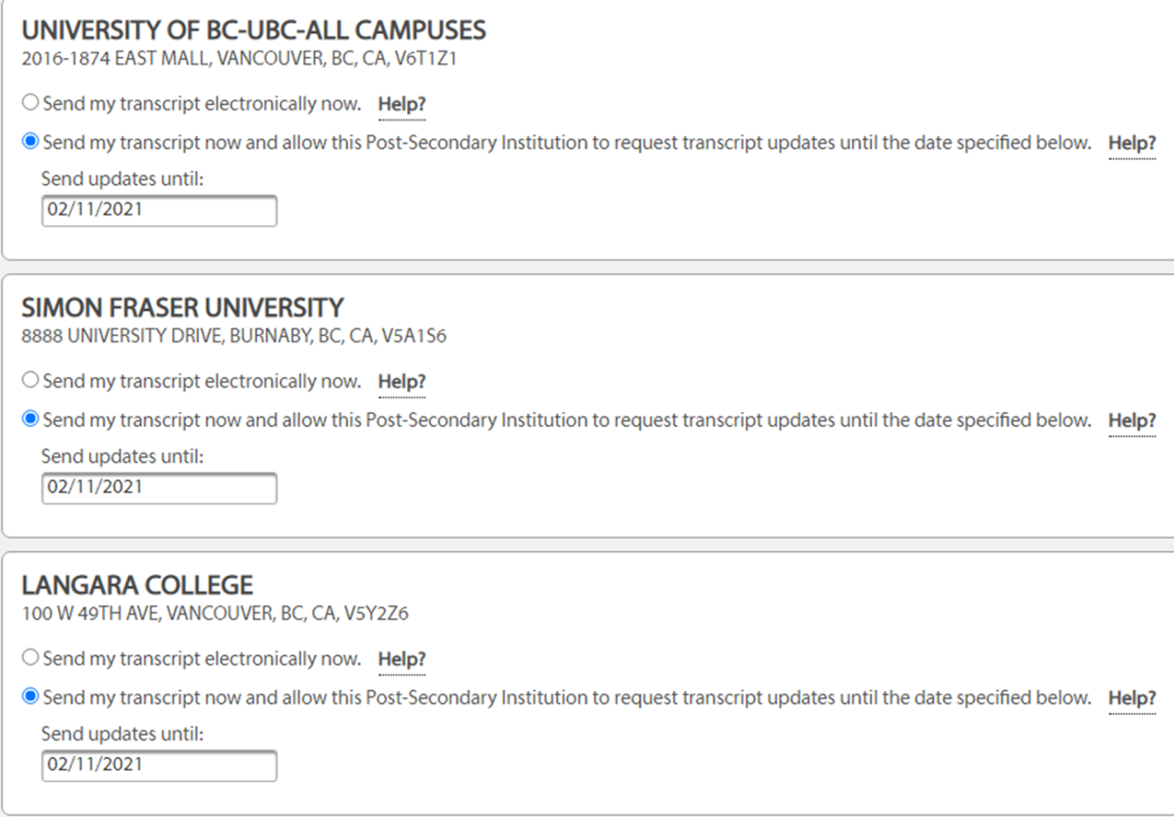

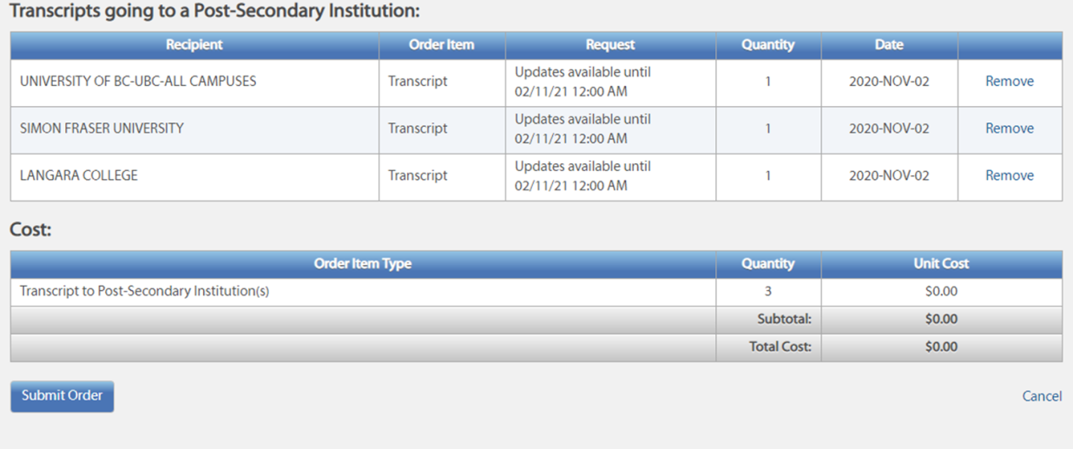
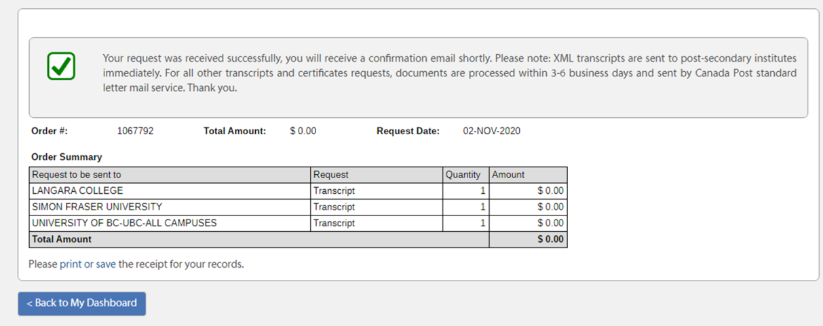

Easy Peasy.

