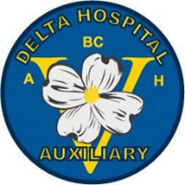
Delta Hospital Auxiliary Office
5800 Mountain View Blvd
Delta, BC V4K 3V6

604-946-1121 Loc 783212
_____________________________________________________________________________________

STUDENT BURSARY

INTRODUCTION
Delta Hospital Auxiliary was formed in 1969, and is a major volunteer service provider and fund-raising organization supporting Delta Hospital. In appreciation for the public support that we have received over the years the Auxiliary now awards six bursaries of $1,500.00 each. Funds are awarded at the discretion of the Auxiliary Bursary Committee.

ELIGIBILITY.
Applicants must be involved in or entering the field of Health Care
Applicant must be a current Delta resident for a period not less than two years
Successful candidate must furnish proof or registration from an approved institution, along with Social Insurance Number, to accounting@dhas.ca by September 15 or forfeit the award.

DOCUMENTATION REQUIRED
Proof of two years residency in Delta
Photocopy of most recent academic records
Two recent letters of reference (school, employment, volunteering)
Proof of validation for volunteer hours
Personal letter detailing financial need for the Bursary, career area chosen, reason for pursuing this career and services made to this community

SUBMISSION
Please complete and submit the application form with all required documentation.
Incomplete applications will not be considered. Faxes and emails will not be accepted.

CLOSING DATE
May 1 annually. The successful applicant will be advised by June 15th.For more information please contact dh.auxiliary@fraserhealth.ca, or call 604-946-1121 L 783212

